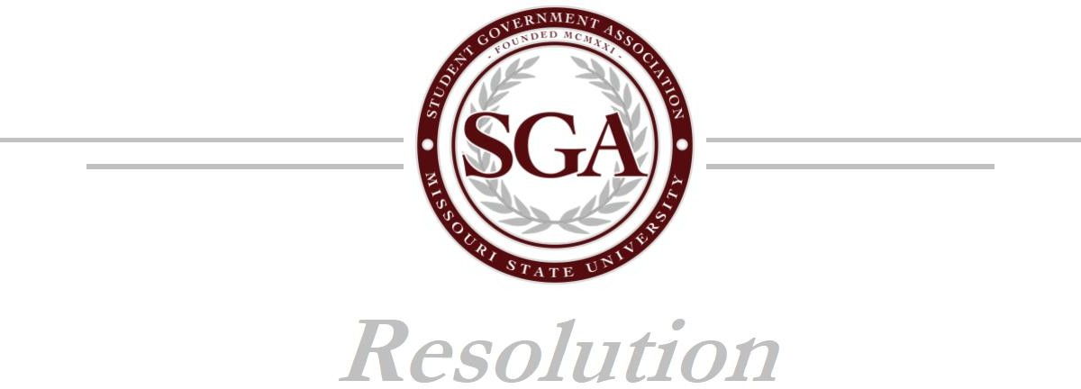

**GB FALL/SPRING 202X-XX: SUPPORT FOR [blank]**

**Authored by: YOUR NAME Sponsored by: COMMITTEE**

**DATE OF FIRST PRESENTATION TO SENATE**

1. WHEREAS the Student Government Association of Missouri State University is the
2. official voice of the student body; and 3
3. RECOGNIZING that the Student Initiative Fund was created in 2016 to support student
4. ideas, projects, and visions; and 6
5. REALIZING that the Student Government Association wants to support the funding of
6. [insert name of department, organization, program you are funding] and the purchase of
7. [YOUR PROJECT]

10

11 REALIZING that the total cost of this project will $ XXXX; and 12

1. NOTING granting the one-time contribution of $ XXXX be an adequate amount for the
2. purchasing of [YOUR PROJECT] 15
3. UNDERSTANDING that the purpose of the Student Initiative Fund is to provide
4. students the funds necessary to see their projects and dreams come to life, and this
5. project meets that description; and 19
6. FURTHER UNDERSTANDING that all Student Initiative Fund proposals must be
7. approved by a two-thirds vote of the Senate; therefore 22
8. BE IT RESOLVED that the Student Government Association of Missouri State
9. University hereby approves the Student Initiative Fund Proposal; and 25
10. BE IT FURTHER RESOLVED that a copy of this resolution be sent to Dr. Andrea
11. Weber; Assistant Vice President for Student Affairs/Dean of Students/SGA Advisor,
12. Kerri Deal; Executive Assistant to the Dean of Students, Dr. Dee Siscoe; Vice President
13. of Student Affairs, Stef Hall; Executive Assistant to the Vice President of Student
14. Affairs, and University Archives [ADD ADDITONAL AS NEEDED]